|  |
| --- |
| Name: |
| Student Reference Number: |



|  |  |  |
| --- | --- | --- |
| Module Code: | Module Name: | |
| Coursework Title: | | |
| Deadline Date: | | Member of staff responsible for coursework: |
| Programme: | | |
| Please note that University Academic Regulations are available under Rules and Regulations on the University website [www.plymouth.ac.uk/studenthandbook](http://www.plymouth.ac.uk/studenthandbook). | | |
| Group work: please list all names of all participants formally associated with this work and state whether the work was undertaken alone or as part of a team. Please note you may be required to identify individual responsibility for component parts.  ***We confirm that we have read and understood the Plymouth University regulations relating to Assessment Offences and that we are aware of the possible penalties for any breach of these regulations. We confirm that this is the independent work of the group.***  Signed on behalf of the group: | | |
| Individual assignment: ***I confirm that I have read and understood the Plymouth University regulations relating to Assessment Offences and that I am aware of the possible penalties for any breach of these regulations. I confirm that this is my own independent work.***  Signed : | | |
| Use of translation software: failure to declare that translation software or a similar writing aid has been used will be treated as an assessment offence.  I *have used/not used translation software.  If used, please state name of software………………………………………………………………… | | |
| **Overall mark _____% Assessors Initials ______ Date_________** | | |

 

NSBM Green University

Faculty of Computing

PUSL 2023 – Mobile Application Development

Group Project Proposal – Group 83

|  |  |  |
| --- | --- | --- |
|  | Group Number | 83 |
|  | Student ID | Name |
| 1 | 10898790 | Karagoda Jayawardhana. |
| 2 |  |  |
| 3 |  |  |
| 4 | 10899406 | Ashini Gunawardhana. |
| 5 |  |  |
| 6 |  |  |

Table of Contents

Introduction 3

Problem Definition 4

Scope of the Project 6

01.Overview: 6

02. Features: 6

•User Registration/Login: 6

•Event Creation: 6

•Participant Invitations: 6

•Calendar Integration: 6

•Voting Mechanism: 6

•Real-time Updates: 6

03. User Roles: 7

Organizer 7

Participants 7

04. Event Dashboard: 7

05. Notifications: 7

06. Security: 7

07. Scalability: 7

08. Timeline: 7

09. Budget: 7

10. Marketing and Launch: 7

Objectives 8

01. Scheduling Efficiency 8

02. User Flexibility 8

03. Automated Reminders 8

04. Time Zone Management: 8

05. Collaborative Decision-Making: 8

06. Integration with Calendars: 8

07. Customization Options: 8

08. Participant Availability Tracking: 9

09. Feedback Mechanism: 9

10. Security and Privacy: 9

Features of Application 9

01. Registration 9

02. Event Creation 9

03.Presenting votes clearly 9

04. Selection 10

05. Timely Notification 10

06. The versatility of voting 10

07. Calendar Integration 10

08. Participant Availability Polls 10

09. Customizable Invitations 10

10. Real-time Updates 10

Diagrams 11

Gantt Chart 11

References List 11

# Introduction

There are many challenges that event planners in organization's have to face when a fixing a date and time for an event in there organization. Therefore, our team decided to create a modern mobile application that any event planner can easily reach and take many advantages than before event planning.

Our team also have considered the advantages of having a mobile application that can easily fix a date and time for any event in any organization. There are time efficiency, reduced conflicts, flexibility, data security, enhanced productivity etc.

The leader of the organization and all its members can connect with this mobile application. They can get together and decide the perfect date and time for their event too.

All parties involved to any changes in dates or times through real-time updates and notifications. By doing this, the organization's communication is improved and everyone is aware of the timetables for the events.

The days of complicated spreadsheets and never-ending email conversations are long gone. All of your organizational events may be easily scheduled, rescheduled, and have their dates and hours synchronized with our app. Users can input preferences, limits, and availability using the user-friendly interface, which streamlines the decision-making process and helps to eliminate potential conflicts.

The app's clever algorithm suggests ideal dates and times by taking into account a number of variables, including participant and venue availability as well as time zone variations.

This increases attendance and reduces the possibility of scheduling problems, guaranteeing the success and high turnout of your events. Collaboration is at the core of our app, with real-time updates and notifications keeping all stakeholders informed. Whether you're planning a team meeting, a training session, or a company-wide conference, our Date and Time Fixing App empowers you to take control of your schedule effortlessly. This is the ultimate solution for seamless event management within your organization.

Our mobile application is made to the seamless and effective operation of your events. With our Date and Time Fixing App, bid logistical headaches a fond farewell and hello to efficiency. Take your corporate events to new heights by making sure that every detail is well thought out and carried out. Welcome to the future of event management with our dependable, creative, and easy-to-use solution.

# Problem Definition

Organizational event planners frequently struggle with the complex problem of scheduling, which emphasizes the necessity of an all-inclusive date and time fixing software. The current environment is characterized by manual procedures, inefficiencies, and the inherent difficulty of juggling conflicting timetables.

First of all, there is insufficient central coordination as a result of the widespread use of various communication channels, such as emails and messaging applications. Due to the decentralized approach's confusion-causing nature, stakeholders find it challenging to reach an agreement on appropriate dates and times as they sort through a maze of messages, attachments, and contradicting information.

Second, it takes a lot of time to schedule an event using the traditional ways. Planning is slowed down by endless email exchanges, spreadsheets, and meetings that take up important resources. This reduces productivity and increases the chance of errors because there are so many channels of communication and manual data entry that information may be missed.

Additionally, the difficulty is made worse by the fact that modern organizations are worldwide in scope. Working with participants who are in various time zones introduces another level of complication, which frequently results in scheduling errors and mismatches that have a detrimental effect on participation and teamwork.

Moreover, a major obstacle is the inability to adjust to changing timetables. It is inevitable that last-minute modifications may occur in the fast-paced business world of today. It is difficult to effectively accommodate changes in the absence of a responsive and agile system, which could lead to disruptions and a reduction in the overall efficacy of the event.

Finally, security issues are a major problem. The secrecy of critical event details may be jeopardized by using traditional communication channels. Organizations are placing a high priority on data security, and an insufficiently secured system increases the danger of unwanted access and jeopardizes the planning process's integrity.

The development of a strong Date and Time Fixing App is required to address these issues and open the door to seamless, secure, and effective organizational event planning. The core cause of the issue is the fragmented, time-consuming, and insecure nature of current event scheduling processes.

# Scope of the Project

## 01.Overview:

Develop a mobile application to assist an organisation schedule and manage activities more effectively.

## 02. Features:

### •User Registration/Login:

Safe authentication procedures for both attendees and coordinators.

### •Event Creation:

Events can be created by organizers, who can provide the details, date, time, and venue.

### •Participant Invitations:

Participant invitation options include email and app notifications.

### •Calendar Integration:

Users' calendars are coordinated to prevent schedule conflicts.

### •Voting Mechanism:

On recommended dates and times for the event, participants can cast their votes.

### •Real-time Updates:

Notifications of event updates, voting outcomes, and decisions made instantly.

## 03. User Roles:

Organizer: Able to plan, coordinate, and complete event details.

Participants: Get information about the event, cast votes on recommended dates, and receive invitations.

## 04. Event Dashboard:

A summary of all the events that are coming up, along with important information.

Status of the vote and comments from participants.

## 05. Notifications:

Push alerts for updated information on the event, vote results, and new invitations.

## 06. Security:

Secure data encryption and user authentication.

## 07. Scalability:

Create the app with the ability to handle an increasing amount of users and events in mind.

## 08. Timeline:

Develop a reasonable development schedule that takes into account every phase, from planning to launch.

## 09. Budget:

Calculate the expenses related to development, testing, and continuing upkeep.

## 10. Marketing and Launch:

Create a marketing plan inside the company for the app launch.

The mobile application will function as a full solution for effective date and time setting for organizational events by taking care of these components.

# Objectives

## 01. Scheduling Efficiency

Give users an easy-to-use interface to choose their preferred date and time for events so they can plan them effectively.

## 02. User Flexibility

Permit users to suggest different times and dates, taking into account a range of schedules and preferences.

## 03. Automated Reminders

To lower the possibility of missed engagements, use automated reminders to inform participants of impending activities

## 04. Time Zone Management:

Include functions that allow for the smooth handling of time zone variations, guaranteeing precise scheduling for participants spread across many locations.

## 05. Collaborative Decision-Making:

Promote group consensus by allowing participants to observe and react to suggested dates. This will aid in collaborative decision-making.

## 06. Integration with Calendars:

To give users a centralized picture of their obligations, synchronize event details with widely used calendar software.

## 07. Customization Options:

Depending on the type of event, provide organizers with the ability to select precise timeslots, durations, and reoccurring patterns.

## 08. Participant Availability Tracking:

Enable organizers to monitor participant availability in real-time with the help of technologies, which will help them make more educated scheduling decisions.

## 09. Feedback Mechanism:

To enable ongoing enhancement of event preparation, develop a feedback mechanism and will gather participant feedback at the designated time and date.

## 10. Security and Privacy:

Make sure that date and time information is handled securely, that user privacy is respected, and that critical event details are shielded from unwanted access.

# Features of Application

## 01. Registration

Organization leader and all the members be able to register to the mobile application. They can add new members, search members, create groups and also select add groups.

## 02. Event Creation

Organization leader and also member can easily create events. They can search and select groups with in titles and also they can see possible dates and required peoples too.

## 03.Presenting votes clearly

Everyone can see votes, voting percentages and peoples who votes.

## 04. Selection

Members be able to taking decisions and easily select perfect dates and times for the event using percentages.

## 05. Timely Notification

When members fix a suitable date and time for a event, send a notification to all the members in a group on time.

## 06. The versatility of voting

All the members can see others votes and everyone can vote any selection. Not only that members also possible to vote more than one selection.

## 07. Calendar Integration

Smooth calendar importation to import current commitments and prevent schedule conflicts.

## 08. Participant Availability Polls

Let the organizers to make availability surveys available to attendees so that preferences can be easily gathered and the best time can be selected.

## 09. Customizable Invitations

Give event planners the option to customize invitations by adding information about the schedule, venue, and any unique requirements.

## 10. Real-time Updates

In order to promote cooperation and communication, give real-time information on participant answers and any modifications to the suggested day and time.

# Diagrams

# Gantt Chart

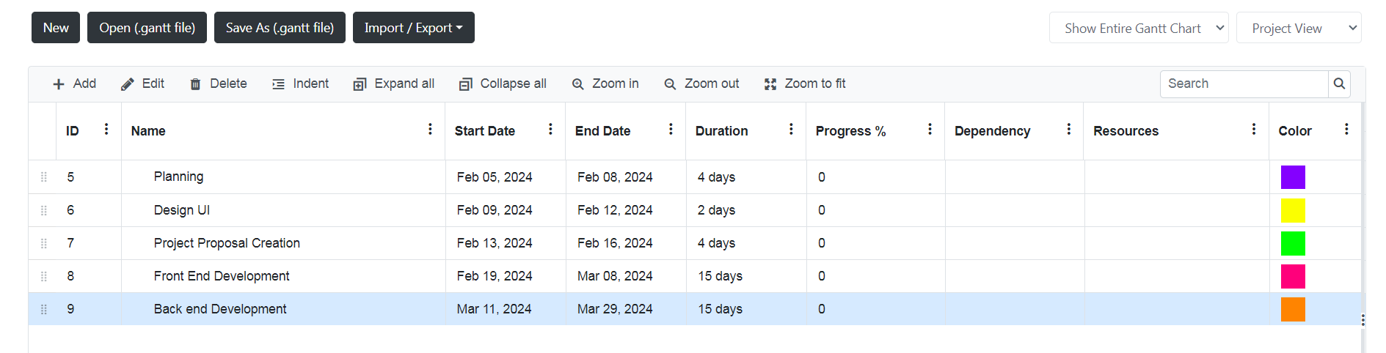

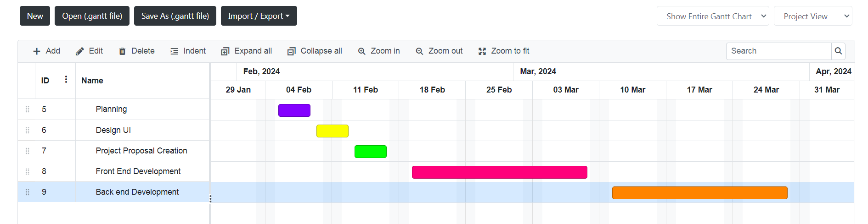

# References List